**Stock Exchange Data Analysis**

DESCRIPTION

**Objective**: To use hive features for data engineering or analysis and sharing the actionable insights

**Problem Statement:**  
NewYork stock exchange data of seven years, between 2010 to 2016, is captured for 500+ listed companies. The data set comprises of intra-day prices and volume traded for each listed company. The data serves both for machine learning and exploratory analysis projects, to automate the trading process and to predict the next trading-day winners or losers.. The scope of this project is limited to exploratory data analysis.

**Domain**: BFSI

**Analysis to be done:** Exploratory analysis to understand how MoM or YoY companies from different sectors or industries and states have progressed in a period of 7 years

**Content:** This data set contains prices.csv and securities.csv files having the following features:

Prices.csv:

1. Date: Trading date
2. Symbol: Ticker code or listed company code on NY stock exchange
3. Open: Intra-day opening price for each listed company
4. Close: Intra-day closing price for each listed company
5. Low: Intra-day lowest price for each listed company
6. High: Intra-day highest price for each listed company
7. Volume: Number of shares traded per day per company

Securities.csv:

1. Ticker_Symbol: Country to which the customer belongs
2. Security: Legal name of the listed company
3. Sector: Business vertical of the listed company
4. Sub_Industry: Business domain of the listed company within a Sector.
5. Headquarter: Headquarters address

**Steps to perform:**

     1) Create a data pipeline using sqoop to pull the data from the table below from MYSQL server into Hive.

a. MYSQL DATABASE NAME: BDHS_PROJECT

i. Stock_prices  
ii. Stock_companies

Check the TABLE description: STOCK_PRICES

|  |  |
| --- | --- |
| Column Name | Datatype |
| Trading_date | Date |
| Symbol | String |
| Open | double |
| Close | double |
| Low | double |
| High | double |
| Volume | int |

TABLE: STOCK_COMPANIES

|  |  |
| --- | --- |
| Column Name | Datatype |
| Symbol | String |
| Company_name | String |
| Sector | String |
| Sub_industry | String |
| Headquarter | String |

2) Create a new hive table with the following fields by joining the above two hive tables.  
Please use appropriate Hive built-in functions for columns (a,b,e and h to l).

* Trading_year: Should contain YYYY for each record
* Trading_month: Should contain MM or MMM for each record
* Symbol: Ticker code
* CompanyName: Legal name of the listed company
* State: State to be extracted from headquarters value.
* Sector: Business vertical of the listed company
* Sub_Industry: Business domain of the listed company within a sector
* Open: Average of intra-day opening price by month and year for each listed company
* Close: Average of intra-day closing price by month and year for each listed company
* Low: Average of intra-day lowest price by month and year for each listed company
* High: Average of intra-day highest price by month and year for each listed company
* Volume: Average of number of shares traded by month and year for each listed company

**DATA ANALYSIS USING HIVE**

         3) Find the top five companies that are good for investment  
         4) Show the best-growing industry by each state, having at least two or more industries mapped.  
         5) For each sector find the following.

* Worst year
* b. Best year
* c. Stable year

Solution:

Use the mysql database to check if tables are present;

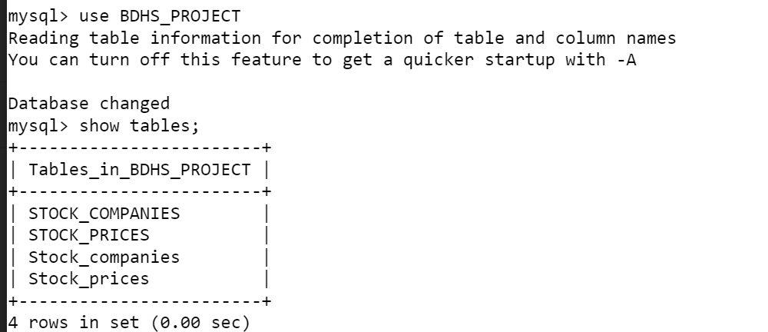

Check table contents

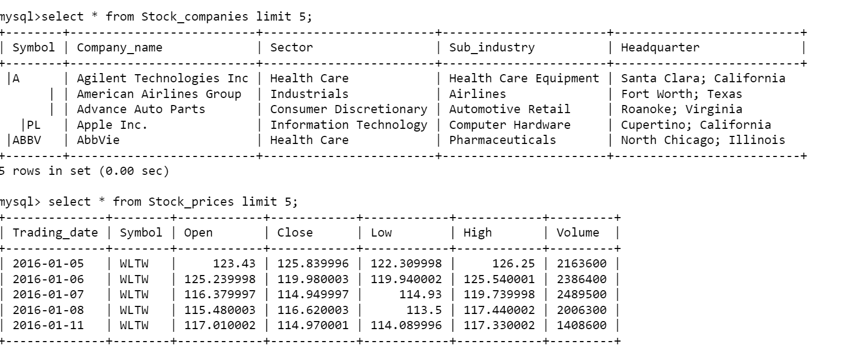

Now import the data from mysql using sqoop to hive

sqoop import --connect jdbc:mysql://localhost/BDHS_PROJECT --username labuser --password simplilearn --table Stock_compaies --hive-import --hive-database stockanalysis -m 1

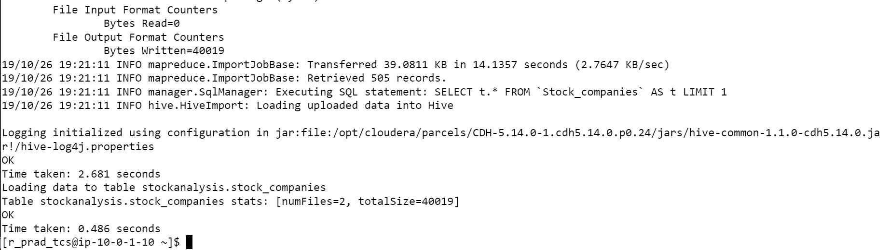

sqoop import --connect jdbc:mysql://ip-10-0-1-10.ec2.internal/BDHS_PROJECT --username labuser --password simplilearn --table Stock_companies –hive-import -hive-database stockanalysis --m 1

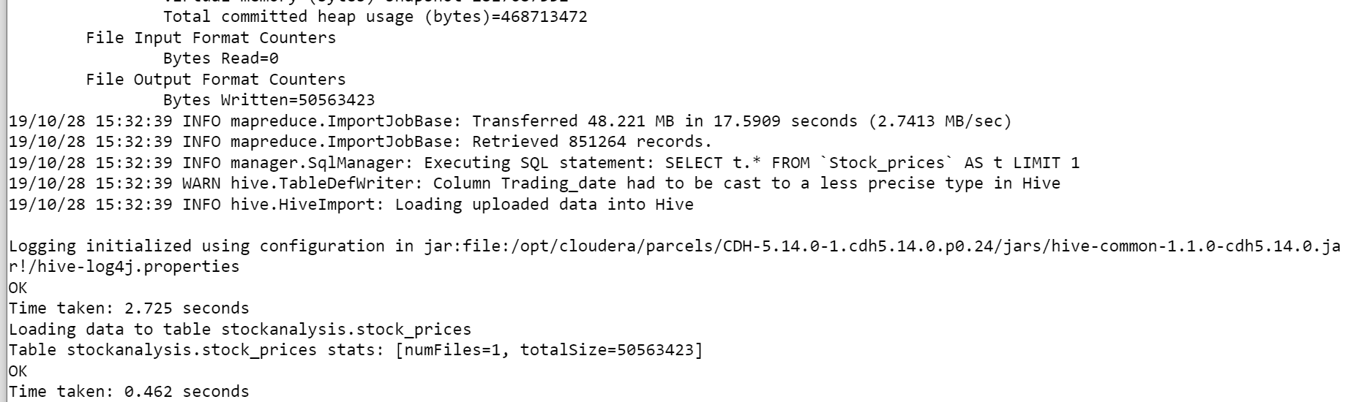

Check contents of hive table:

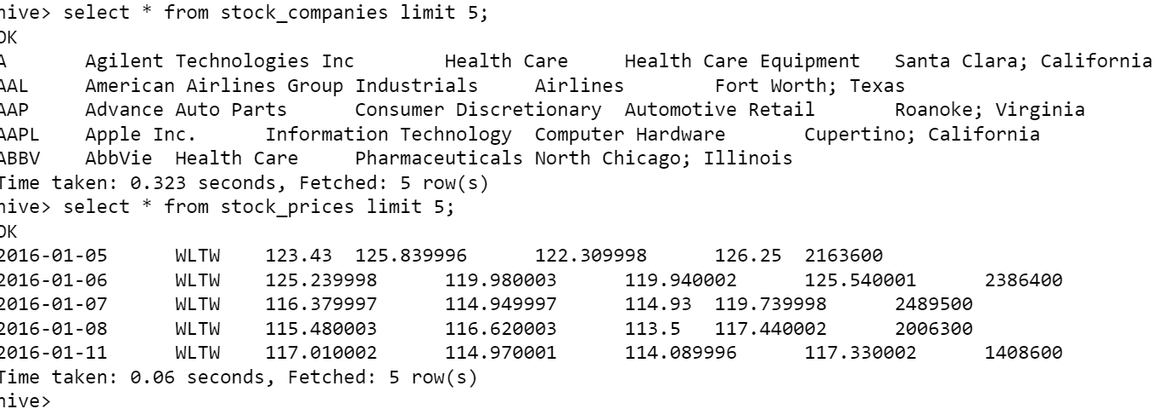

Create a new hive table by joining the above 2 hive tables by using appropriate hive built in functions for columns(a,b,e,h to l)

create table stock_data as select trading_year,

trading_month, sc.symbol, company_name, trim(split(headquarter,”\;”)[1]) state,

sector, sub_industry, open, close, low, high, volume

from stock_companies sc,

(select symbol, year(trading_date) trading_year, month(trading_date) trading_month,

round(avg(open),2) open, round(avg(close),2) close, round(avg(low),2) low,

round(avg(high),2) high, round(avg(volume),2) volume

from stock_prices

group by symbol, month(trading_date),year(trading_date)) sp

where sc.symbol=sp.symbol;

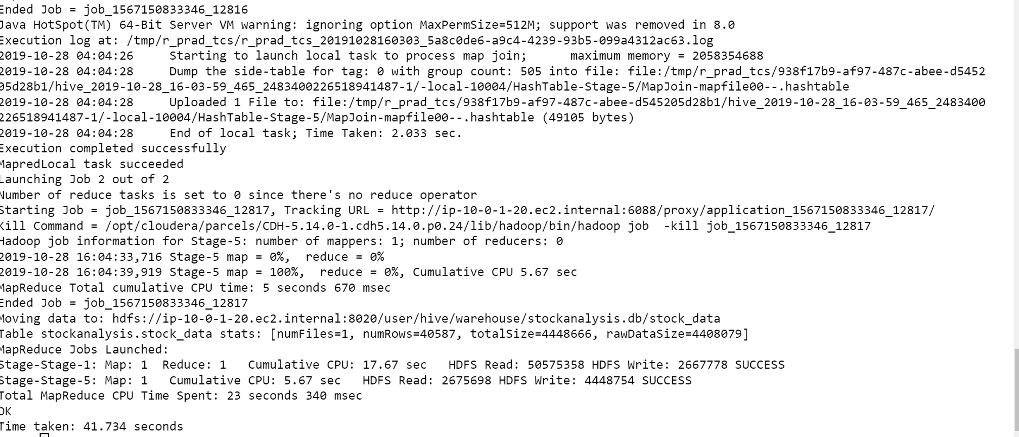

Select * from stock_data limit 5;

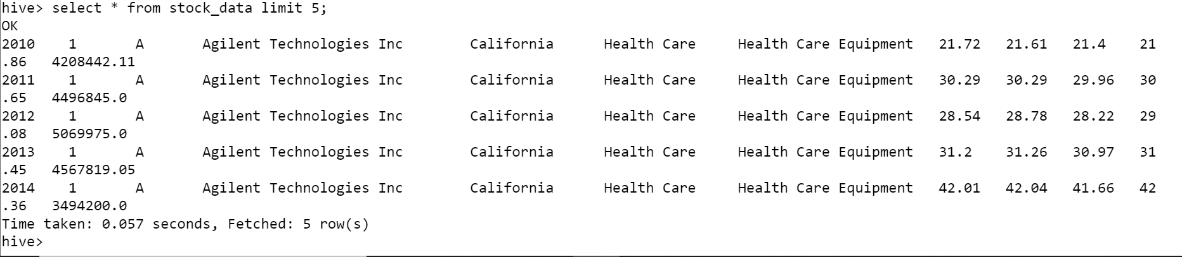

Find the top five companies that are good for investment

Step 1: Create a temp table with required data for analysis

create table company_horizon as select

company_name, min(trading_year) min, max(trading_year) max,

min(trading_month) min_month, max(trading_month) max_month

from stock_data

group by company_name;

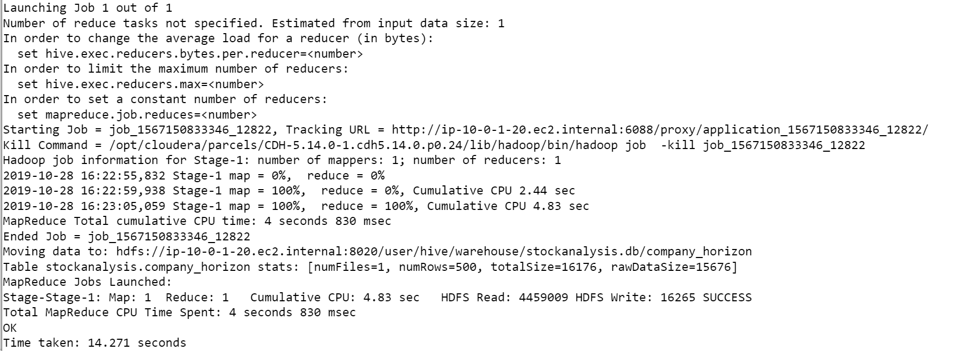

Step 2: Alalyze based on the data in temp table created to identify the growth of a company.

select stock_start.company_name,

((close-open)/open)*100 growth_percent

from (select chv.company_name, open from stock_data sd, company_horizon chv

where sd.trading_year = chv.min_year

and sd.trading_month = chv.min_month

and sd.company_name = chv.company_name) stock_start,

(select chv.company_name,close from stock_data sd, company_horizon chv

where sd.trading_year = chv.max_year

and sd.trading_month = chv.max_month

and sd.company_name = chv.company_name) stock_end

where stock_start.company_name = stock_end.company_name

sort by growth_percent desc limit 5;

This shows the top 5 companies by growth